**EXIT TICKETS – 4.1.4. a,b,c,d – Mutations – QUESTIONS**

(4.1.4 a)

An error in the replication of DNA that occurs inside one DNA nucleotide triplet where there is a substitution of one nucleotide for another, or the order within the triplet is changed, is referred to as

* (A) frame shift mutation
* (B) a point mutation
* (C) a chromosomal block mutation
* (D) a non-disjunction mutation

(4.1.4 a)

A failure of homologous chromosomes or sister chromatids to separate during cell devision, is referred to as

* (A) frame shift mutation
* (B) a point mutation
* (C) a chromosomal block mutation
* (D) a non-disjunction mutation

(4.1.4 b)

Explain how non-disjunction leads to Aneuploidy (3 marks)

**PA MOCKEXAM 2020 SA 2** (4.1.4 c)

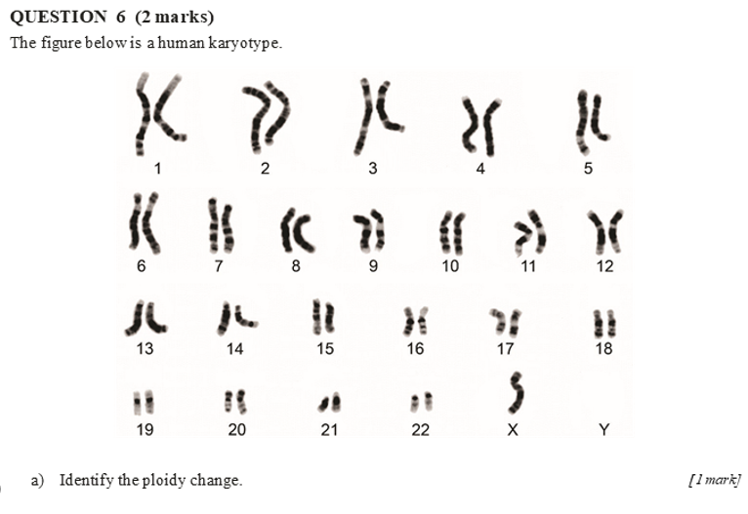

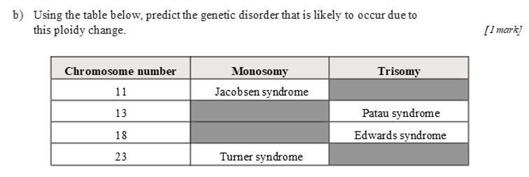**at 23 chromosome lacking either another x chromosome or y.**

**PREVIOUS EXAM 2020 SA 1 (4.1.4 d)**

**QUESTION 24**

**b)** Inherited mutations can affect the genotype of offspring. Describe how this occurs.

*[2 marks]*

**SO MOCKEXAM 2020 SA 1 (4.1.4 a)**

**QUESTION 24 (2 marks)**

Explain how damage caused by ultraviolet (UV) radiation can cause mutations in DNA.

**EXIT TICKETS – 4.1.4. a,b,c,d – Mutations – ANSWERS**

(4.1.4 a)

An error in the replication of DNA that occurs inside one DNA nucleotide triplet where there is a substitution of one nucleotide for another, or the order within the triplet is changed, is referred to as

* (A) frame shift mutation
* (B) a point mutation
* (C) a chromosomal block mutation
* (D) a non-disjunction mutation

(4.1.4 a)

A failure of homologous chromosomes or sister chromatids to separate during cell devision, is referred to as

* (A) frame shift mutation
* (B) a point mutation
* (C) a chromosomal block mutation
* (D) a non-disjunction mutation

(4.1.4 b)

Explain how non-disjunction leads to Aneuploidy (3 marks)

During meiosis, homologous chromosomes pair up next to each other prior to separating. The failure of one or more pairs of homologous chromosomes or sister chromatids to separate normally is referred to as non-disjunction.

This usually results in an abnormal distribution of chromosomes in the daughter nuclei.

In such situations the resulting gametes will either gain one or more chromosomes or lose them and thus the resulting offspring can inherit an abnormal number of chromosomes. This abnormal chromosomal number is referred to as aneuploidy

**PA MOCKEXAM 2020 SA 2** (4.1.4 c)



There has been a change to the sex chromosomes



The disorder that is likely to occur is Turner syndrome (as the Chromosome number is 23)

**PREVIOUS EXAM 2020 SA 1 (4.1.4 d)**

**QUESTION 24**

**b)** Inherited mutations can affect the genotype of offspring. Describe how this occurs.

*[2 marks]*

The parent of the offspring would have a mutation that is inheritable (in sex organs) and creates a new allele (variation of a gene).

The genotype of an offspring may then be affected as it would contain new alleles if the mutated gene from an egg or sperm is present in the zygote at fertilisation. This will then affect the genotype of the offspring.

**SO MOCKEXAM 2020 SA 1 (4.1.4 a)**

**QUESTION 24 (2 marks)**

Explain how damage caused by ultraviolet (UV) radiation can cause mutations in DNA.

UV radiation changes the DNA structure, e.g. bends the DNA, causing the DNA to be read incorrectly and leading to mutation.

UV radiation breaks the DNA molecule potentially causing a mutation, e.g. cancer, if DNA repair doesn’t occur.